Config A:
Configuration |  | Result
Lr (learning Rate) | Weight_Decay | Result | Accuracy | Conf Mat
1e-4 | 1e-4 | 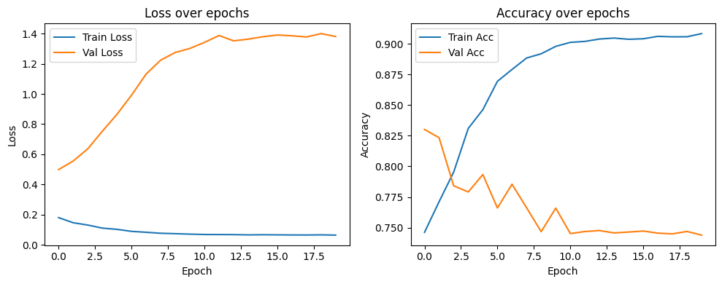 | 0.7635939063716224 | 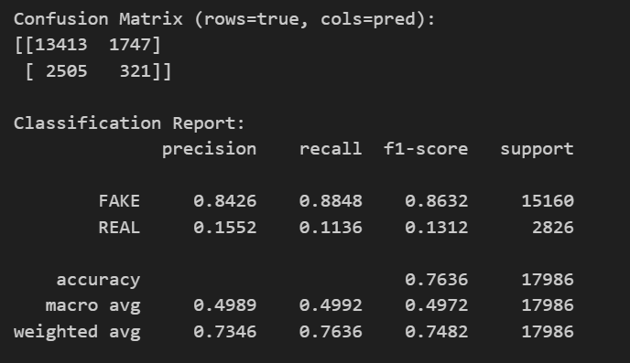
3e-4 | 1e-4
1e-4 | 5e-4

